COMP9032 Project Design Manual

Name:Ran Bai zID:5187292

1.Introduction
Cup and Ball is an online game where a ball is shuffled under three cups and player guess the position of the ball. For each guess, gain one point if it is correct or lose one point if it is wrong.
In this system, the push button is used to start the game; Three LEDs are used to represent the three cups, and these LEDs together with the motor are also used to indicate the ball shuffling among the three cups; the key board (replacing the mouse in the original game) is used for the player to make a guess; the player’s score is displayed on LCD. For the LED bar on the lab board, two groups of LEDs are used. Three LEDs, called cup LEDs, are associated with three cups and the four LEDs of the other group work as a result indicator for a guess. When a guess is correct, the indicator will flash.

2.Design flow chart
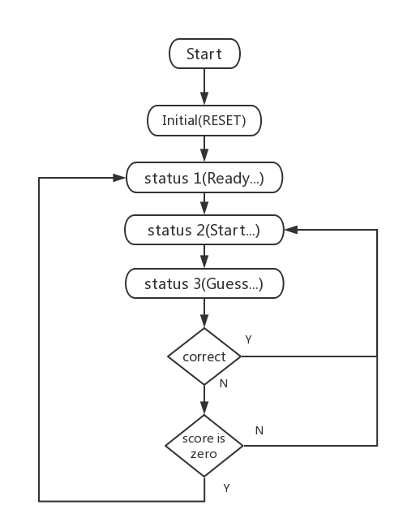

3.Design Detail
Each operation of the system and the related inputs/outputs are described below.
- After the simulation system is turned on (i.e. the lab board is powered on), the system is initialized and the ball is with an arbitrarily cup. In this case,
a.“Ready…” is displayed on LCD;
b. The cup LED with the ball is on, where the ball is with Cup 3. Other LEDs are off.

In the RESET section, the defined registers, Timer, interrupt, LCD screen and port are initialized. I assume that RESET is the first state of the entire system and complete the corresponding operation in operation one here.

- When the push button is pressed, the game starts and the ball is shuffled under the three cups. In this case,
- “Start …” is displayed on LCD;
- Motor spins;
- Three cup LEDs are all on, but in dimmed light; other LEDs remain off.

I assume this part is status 2. The interrupt generated by pressing the button enters this state. Timer5 is set to generate a PWM signal, and timer0 is set to periodically trigger an overflow interrupt. Therefore, the three LEDs emit dim light can through timer0 to periodically copy the PWM signal generated by timer5 to the three LEDs.

- When the player wants to make a guess for the ball position by pressing the push button again, the ball shuffle stops. In this case,
- The motor stops;
- The three cup LEDs remain dimmed;
- After the player keys in the ball position on the key pad, the cups are removed, the ball position is uncovered and the score is determined. In this case,
i.The cup LED with the ball is fully on, where the ball is now with Cup 2;
ii.If the player’s guess is correct, the score on the LCD is incremented by 1 and the indicator will flash a few times; otherwise,
iii. If the guess is incorrect, the score on LCD is decremented.

I assume this part is status 3. By pressing the button again, it switches from state 2 to state 3. Similarly, the corresponding operation is completed by interrupt. The random number is a pseudo-random number generated by a timer0 clock source according to a certain algorithm. A special register is used to store the score in the entire game, and the score is incremented or decremented by comparing the number entered by the keypad with the random number.

- When the player’s score becomes zero, the game will be reset to the initial start status; otherwise, the game can be continued by pressing the button for a new round of ball shuffle.

In this part, after the ball is not under the cup we guessed, if the current score is less than or equal to one point, it jumps back to state one, the RESET part. It can be achieved when the player scores equal to 0, returning to the initial state.

